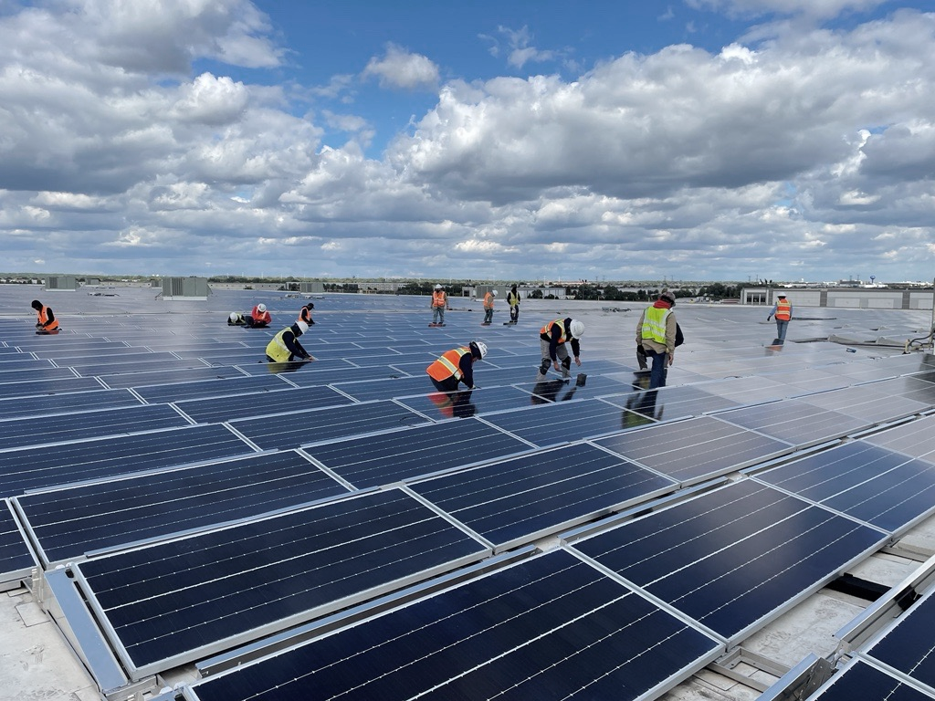


Health Assessment inspection

(RSD Safety focus)

Catalyze Project #18263 - Bloomington, CA

PREPARED FOR:


6/20/2025
Jason Core
Head of Pre-Construction
Catalyze

Jason,

Thank you for engaging HelioVolta LLC. The HelioVolta team is pleased to present the following proposal for engineering support, in the form of a Health Assessment Inspection, with a focus on the rapid shutdown devices (RSD) currently installed at Catalyze Project #18263.

HelioVolta is a technical advisory firm with a focus on solar and energy storage technology. Our mission is to promote long-term client success with sustainable energy assets by providing outstanding technical services.

Our team has more than 110 years of experience in the solar and energy storage industries and over 10 GW of combined experience working as technical advisors.

Please note that this proposal is valid for two weeks from the date above.

Sincerely,

David Penalva
+1 760.579.9968
david@heliovolta.com

Contents
Background 3
Statement of Work 4
Health Assessment Inspection 4
Fee for Service 5
Terms 6
Contact Information 6
Appendix A: ISO 2859-1 Sample Size Selection 7
Appendex B: Detailed Scope of Work – Health Assessment Inspection 8

Background
Catalyze (Client) is seeking third-party engineering support to assess the long-term risk profile and overall site safety of their rooftop solar system located in Bloomington, CA. The goal is to provide the client with a clear understanding of the sites’ readiness to be safely operated.

Project Details
Project Name | 18263 - LINEAGE - 2551 LILAC AVE
Project Location | 2551 S Lilac Ave, Bloomington, CA 92316
System size (kW_{DC}) | 2.82MW DC MW_{DC}
System size (kW_{AC}) | 1.50MW AC MW_{AC}
Rapid Shutdown Device (RSD) | Northern Electric Power (NEP)
Inverter | Delta 125kW
Module | ZNSHINE SOLAR, ZXM6-72-395/M (395W)

Statement of Work

Health Assessment Inspection
- Description: The Health Assessment Inspection aims to identify safety and quality-related risks of operational systems. This scope consists of an engineering design review, comprehensive visual and thermal inspection. HelioVolta uses a detailed checklist with 300+ points combined with a statistically significant sampling approach - ISO 2859 (Appendix A) - to maximize findings and minimize risk. A detailed scope of work is located in Appendix B.
  - This investigation will have a specific focus on the safety, risk, and long-term quality of the installed Rapid Shutdown Devices.

- Client Requirements: HelioVolta will require the presence of a field technician from the EPC or installation contractor(s) during each inspection to operate the system, including opening and closing enclosures, inverters, and other components that require verification. Additionally, HelioVolta will require the following documentation or information before starting:
  - System design and engineering drawings
  - Component specifications and data sheets
  - Commissioning documentation, and testing data
  - List of known outstanding items (existing punch list)
  - Site personnel contact information
  - Lift or ladder to access equipment, as needed

- Deliverables: A comprehensive inspection report will be provided after each inspection, including an executive summary outlining the general findings and concerns. All issues found will be documented with photo evidence, location, descriptions, and assessed severity. Reports will be delivered in a digital format via the SolarGrade platform, with the option for PDF download if desired.

- Work Schedule: HelioVolta will coordinate logistics with the Client to perform the inspection as soon as possible. A summary report of findings will be provided within 10 days of completion of on-site work.

Fee for Service
For the execution of the Services described in the Statement of Work, the Client agrees to pay HelioVolta a fixed fee for services in the pricing table below.

Scope of work item(s) | Fee
Health Assessment Inspection | $ 11,000
Estimated Travel* | $ 1,000
Estimated Total | $ 12,000

Travel expenses are estimated and will be billed at an actual +5% administration cost. Travel time is billed at 50% cost. Any travel time booked less than 2 weeks from approval of the proposal is billed at full cost.

Engineering Rate Structure (2025) | Hourly Rate
Admin | $ 125
Associate Engineer/Project Manager | $ 210
Engineer/Project Manager/Specialist/Scientist | $ 240
Senior Engineer/Project Manager/Specialist/Scientist | $ 285
Principal Engineer/Manager/Specialist/Scientist | $ 310
Senior Principal Engineer/Manager/Specialist/Scientist | $ 360
Director / VP / Executive | $ 570

Terms
Event | Percent of Payment
Contract Signed | 50%
Final Deliverables Submitted | 50%

Contact Information

Each party agrees that the respective individuals listed below have full authority to direct and provide feedback relating to the project described in this Statement of Work. Either party may change its contact from time to time, upon written notice or email to the other party:

HelioVolta Contact:
Name | David Penalva
Title | Co-founder
Tel No. | +1 760.579.9968
Email | david@heliovolta.com

Client Contact:
Name
Title
Tel No.
Email

IN WITNESS WHEREOF, the parties have caused this SOW to be executed by their duly authorized officers or representatives.

CLIENT HELIOVOLTA

By:______________________________ By:________________________________
Name:____________________________ Name:______________________________
Title:_____________________________ Title:_______________________________
Date:_____________________________ Date:_______________________________

Appendix A: ISO 2859-1 Sample Size Selection
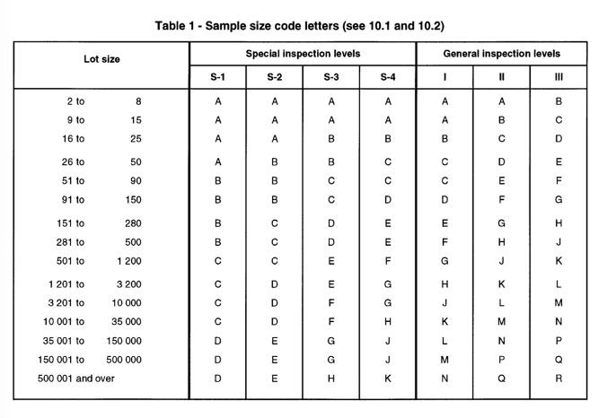
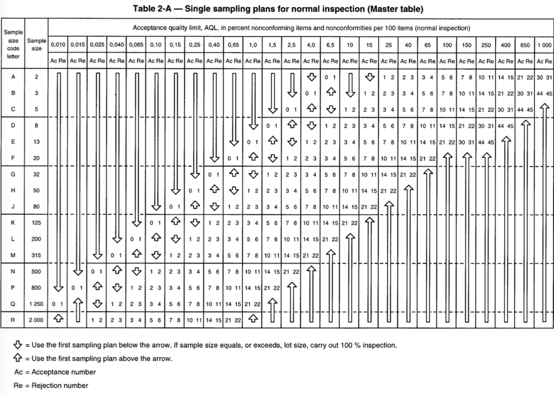

Appendex B: Detailed Scope of Work – Health Assessment Inspection
DESCRIPTION | The health assessment inspection aims to identify safety and quality-related risks of operational systems. This scope consists of an engineering design review, comprehensive visual and thermal inspection. HelioVolta uses a detailed checklist with 300+ points combined with a statistically significant sampling approach - ISO 2859- to maximize findings and minimize risk.
BEST FOR | This inspection is best for technical audits to assess the overall health condition. Mostly focused on safety, quality, and reliability.
REPORTING | 5 days from the inspection
DETAILED SCOPE OF WORK |  | HEALTH ASSESSMENT INSPECTION
Documentation review |  | Full set
Engineering drawings review |  | Full set
O&M Logs |  | Included
Visual Inspection: Safety hazards, damage, bad practices, workmanship, code compliance, improper installation, abnormal conditions, misalignments, corrosion, labels, torque, improper operation, breakages, loose connections, water/moisture intrusion, positioning, bonding, grounding…
- General site condition |  | 100%
- Interconnection and metering |  | 100%
- AC protections: AC disconnects and AC breakers |  | 100%
- Inverters (central, microinverters, or string) |  | Sample ISO 2859
- Rapid shutdown, optimizers, and other MLPE |  | Sample ISO 2859
- DC Distribution system and wire management |  | Sample ISO 2859
- Combiner Boxes |  | Sample ISO 2859
- Field-made connectors |  | Sample ISO 2859
- Factory-made connectors |  | Sample ISO 2859
- Modules |  | Sample ISO 2859
Thermal imaging: Hot connections, outside temperature range, hot spots, temperature deltas, excessive temperatures…
- AC protections and AC breakers, terminations |  | Sample ISO 2859
- Inverters (central, string, or microinverters) |  | Sample ISO 2859
- DC Distribution system, splices, junction boxes, and terminations |  | Sample ISO 2859
- Rapid shutdown, optimizers, and other MLPE |  | Sample ISO 2859
- Combiner Boxes, terminations |  | Sample ISO 2859
- Field-made connectors |  | Sample ISO 2859
- Factory-made connectors |  | Sample ISO 2859
- Modules |  | Sample ISO 2859
IV-Curve tracing |  | Not included
I_{SC} – V_{OC} measurements |  | Not included
Insulation resistance test |  | Not included
Continuity testing |  | Not included
Punch list generation |  | Included

